Software Prototyping Model is a software development methodology that involves creating an initial prototype of the software product before developing the final product. The prototype is a working model of the software product that can be used to gather feedback and refine the design before the final product is developed. The prototyping model is particularly useful for projects where the requirements are not well-defined or are likely to change over time. The prototyping model can help to reduce the risk of developing a software product that does not meet the needs of end-users or stakeholders, while also reducing development time and cost. The prototyping model can be used in conjunction with other software development methodologies, such as agile development, to create software products that meet the needs of end-users and stakeholders.
Prototype Model

Prototyping is a software development methodology that focuses on the use of working models that are constantly refined based on feedback from the end user. Prototyping is most commonly used to develop systems with significant end-user interaction and complex user interfaces.

Because it allows for the capture of customer requirements at an early stage of development, software prototyping is becoming increasingly popular as a software development model. It allows for valuable customer feedback and assists software designers and developers in understanding what is expected directly from sales.

The term "software prototyping" refers to the process of creating software application prototypes that demonstrate the functionality of the product under development but may not contain the exact logic of the original software.

- A prototype can be a limited-functionality software performance model.
- The prototype does not always contain the exact logic used in the specific software application and is an additional effort to be considered when estimating effort.
- Prototyping is used to allow users to evaluate and test developer proposals before they are implemented.
- It also aids in understanding the user-specific requirements that will not be considered by the developer during product design.
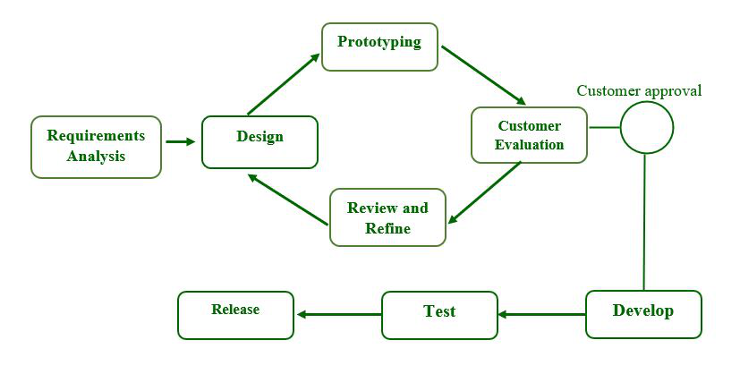
Prototyping Model has six SDLC phases as follows:

Step-1: Requirements gathering and analysis :
Requirement analysis is the first step in developing a prototyping model. During this phase, the system's desires are precisely defined. During the method, system users are interviewed to determine what they expect from the system.
Step-2: Quick design :
The second phase could consist of a preliminary design or a quick design. During this stage, the system's basic design is formed. However, it is not a complete design. It provides the user with a quick overview of the system. The rapid design aids in the development of the prototype.
Step-3: Build a Prototype :
During this stage, an actual prototype is intended to support the knowledge gained from quick design. It is a small low-level working model of the desired system.
Step-4: Initial user evaluation :
The proposed system is presented to the client for preliminary testing at this stage. It is beneficial to investigate the performance model's strengths and weaknesses. Customer feedback and suggestions are gathered and forwarded to the developer.
Step-5: Refining prototype :
If the user is dissatisfied with the current model, you may want to improve the type that responds to user feedback and suggestions. When the user is satisfied with the upgraded model, a final system based on the approved final type is created.
Step-6:Implement Product and Maintain :
The final system was fully tested and distributed to production after it was developed to support the original version. To reduce downtime and prevent major failures, the programmer is run on a regular basis.

Advantages of Software Prototyping :
- Users help to shape the future. As a result, errors can be discovered during the first stage of the software development process.
- Prototyping is also considered a risk reduction function because it allows non-existent performance to be seen, lowering the risk of failure.
- Assists team members in effectively communicating.
- Customer satisfaction exists, and he can feel the product from the start.
- There will be no risk of software loss.
- Quick user feedback aids in the development of better software solutions.

Disadvantages of Software Prototyping :
- Prototyping is a time-consuming and labor-intensive process.
- The cost of creating a specific type of waste is completely wasted because the prototype is eventually discarded.
- Prototyping may result in an overabundance of change requests.
- Customers may be unwilling to commit to the iteration cycle for an extended period of time.
- During each customer test, there may be too many variations in software requirements.
- Poor documentation as a result of changing customer needs.

The Spiral Model is one of the most important SDLC model. The Spiral Model is a combination of the waterfall model and the iterative model. It provides support for Risk Handling.

The Spiral Model is a Software Development Life Cycle (SDLC) model that provides a systematic and iterative approach to software development. In its diagrammatic representation, looks like a spiral with many loops. The exact number of loops of the spiral is unknown and can vary from project to project. Each loop of the spiral is called a phase of the software development process.

Some Key Points regarding the Stages of a Spiral Model:
- The exact number of phases needed to develop the product can be varied by the project manager depending upon the project risks.
- As the project manager dynamically determines the number of phases, the project manager has an important role in developing a product using the spiral model.
- It is based on the idea of a spiral, with each iteration of the spiral representing a complete software development cycle, from requirements gathering and analysis to design, implementation, testing, and maintenance.

Phases of the Spiral Model:


The Spiral Model is a risk-driven model,
meaning that the focus is on managing
risk through multiple iterations of the
software development process.
Each phase of the Spiral Model
is divided into four Quadrants:
Spiral Model

Objectives Defined

In first phase of the spiral model we clarify what the project aims to achieve, including functional and non-functional requirements.
Requirements are gathered from the customers and the objectives are identified, elaborated, and analyzed at the start of every phase. Then alternative solutions possible for the phase are proposed in this quadrant.

Risk Analysis and Resolving

In the risk analysis phase, the risks associated with the project are identified and evaluated.
During the second quadrant, all the possible solutions are evaluated to select the best possible solution. Then the risks associated with that solution are identified and the risks are resolved using the best possible strategy. At the end of this quadrant, the Prototype is built for the best possible solution.

Develop the next version of the Product

During the third quadrant, the identified features are developed and verified through testing. At the end of the third quadrant, the next version of the software is available.
In the evaluation phase, the software is evaluated to determine if it meets the customer's requirements and if it is of high quality.

Review and plan for the next Phase

In the fourth quadrant, the Customers evaluate the so-far developed version of the software. In the end, planning for the next phase is started.
The next iteration of the spiral begins with a new planning phase, based on the results of the evaluation.

